**CONG TY CO PHAN XAY D1/NG COTECCONS**

***COTECCONS CONSTRUCTION JOINT STOCK COMPANY***

**C<)NG HOA XA H<)I CHU NGHiA VI¥T NAM**

**D9c l�p - Tt,r do - H:,mh phuc**

**THE SOCIALIST REPUBLIC OF VIETNAM**

**Independence - Freedom - Happiness**

*TP. H6 Chi Minh, ngay Jd thang i nam 2024 Ho Chi Minh city, day****JO*** *month i. year 2024*

**CONG BO THONG TIN ĐỊNH KỲ**

***REGULAR INFORMATION DISCLOSURE***

**Kinh gui/ *To:* - Uy Ban Chrrng Khoan nha mr&c/ *State Securities Commission of Vietnam***

**- S& Giao djch Chrrng khoan Vi�t Nam/ SO' Giao djch Chrrng khoan Ha N9i/ SO' Giao djch Chrrng khoan thanh ph6 H6 Chi Minh/ *Vietnam Exchange/ Hanoi Stock Exchange/ Hochiminh Stock Exchange***

1. Ten t6 *chfrc/Name of organization:* Cong ty C6 ph�n Xay Dlrng Coteccons Ma chfrng khoan/Ma thanh vien/ *Stock code/ Broker code:* CTD

Dia *chi/Address:* 236/6 Di�n Bien Phu, P.17, Q. Binh Thi;mh, TP. HCM Di�n thol;li lien ***M!Tel.:*** (84) (28) 35142255 - Fax: (84) (28) 35142277

E-mail: [bodsecretary@coteccons.vn](mailto:bodsecretary@coteccons.vn)

1. N(>i dung thong tin cong *b6/Contents of disclosure:*

Bao cao quan tri nam 2023/ *Report on 2023 Corporate Governance (CG).*

Ban cung dp thong tin vS quan tri Cong ty nam 2023/ *Provide information about the 2023 CG of the Company.*

Bao cao tinh hinh thanh toan g6c, lai trai phi6u doanh nghi�p ky 0 l/0 l/2023-31/12/2023/ *Report on the principal and interest payment status of bonds for the period .ft'om Janua,y OJ, 2023, to December 31, 2023.*

Bao cao tai chinh rieng Quy 2/2024 va Giai trinh chenh !�ch trong thuy6t minh/ *Financial report for the second quarter o/2024 and explanation of variances in the disclosures.*

Bao cao tai chinh hqp nhfrt Quy 2/2024 va Giai trinh chenh l�ch trong thuy6t minh/ *Consolidated financial report for the second quarter o/2024 and explanation of variances in the disclosures.*

Thông tin này đã được công bố trên trang thông tin điện tử của công ty vào ngày 30/01/2024 tại đường dẫn: https://coteccons.vn/investor-relations-vn/

*This information was published on the company’s website on 30/01/2024 (date), as in the link https://coteccons.vn/ investor-relations-vn*

Chung toi xin cam kSt cac thong tin cong b6 tren day la dung sµ th�t va hoan toan chiu trach nhi�m tm6c phap lu�t vS n<)i dung cac thong tin da cong b6/ *We hereby certify that the information provided is true and correct and we bear thefill! responsibility to the law.*

***Tai /if****ll* ***{tin!, keml Attached documents***

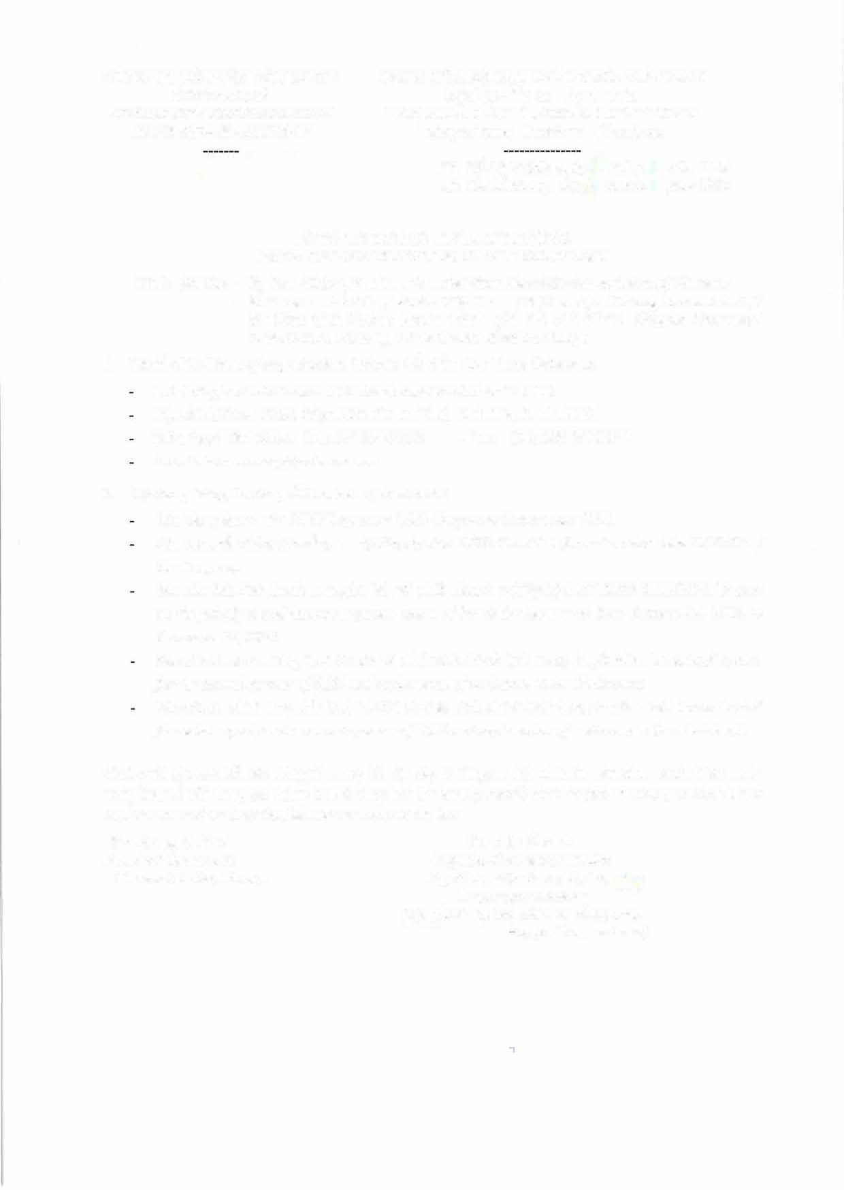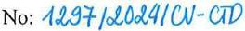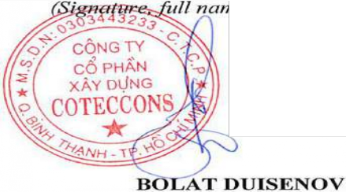

- *Nhu mite 2 Thong baa nay.*

**D�i di�n t6 chrrc *Organization representative*** Nguoi dl;li di�n theo phap lu�t ('\'y'

*Legal representative*

*(Ky, ghi ri5 h9 ten, chfrc V{I, dong ddtJ*

*1e, position, and seal)*

